**App & Web Server.**

1. **Install nginx and run nginx on port number 81.**

Yum install nginx –y

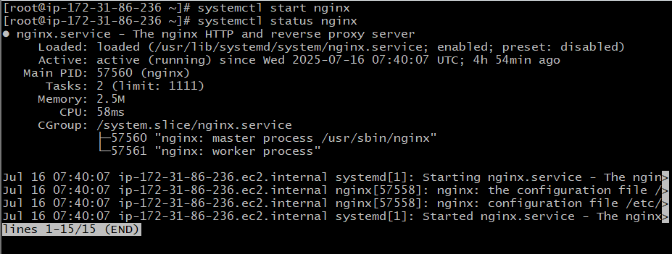

cd /etc/nginx

# vi nginx.conf

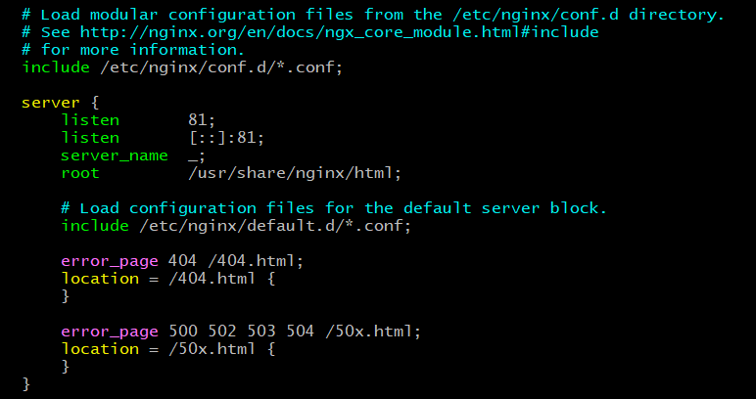

]# systemctl restart nginx

]# systemctl status nginx

We have to copy the public ip and add the port no.to it {http://13.221.108.219:81}

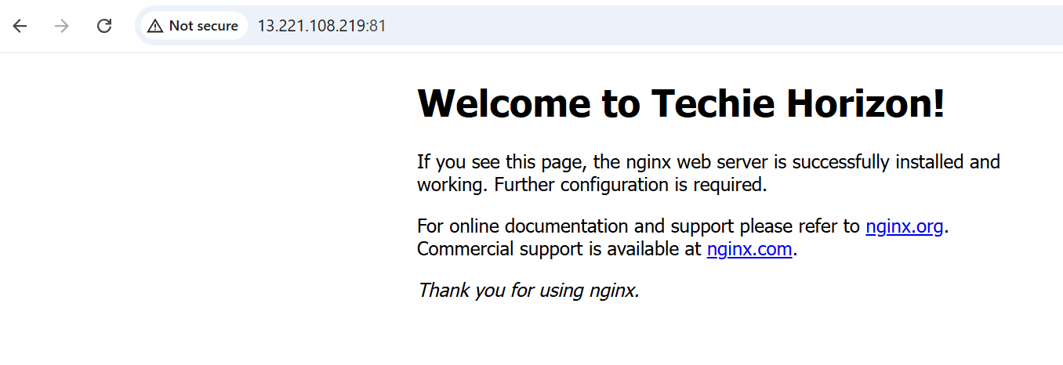

1. **Deploy a sample index.html file on nginx.**

cd /usr/share/nginx/html/



Vi index.html

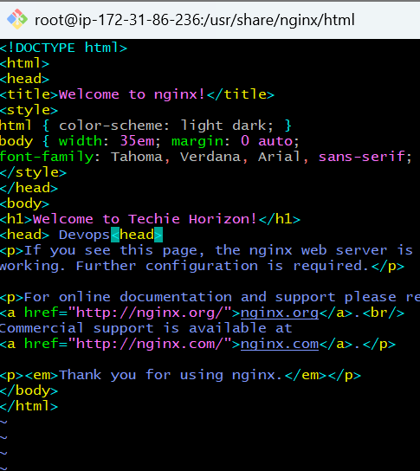

systemctl restart nginx

systemctl status nginx

and then refresh the page

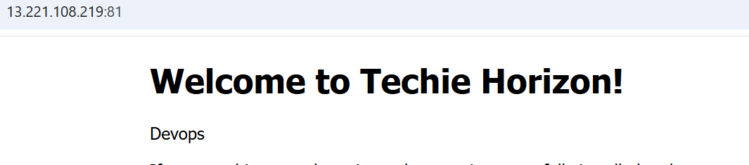

1. **Install Apache and run Apache on port number 82**

Yum install httpd

Systemctl start httpd

To check if it is running

Systemctl status httpd

Netstat –na | grep 80

Ps –ef httpd

To change th port no:-

Cd /etc/httpd/conf

Ls

Ll

Cat httpd.conf

Vi httpd.conf

Systemctl start httpd

Systemctl status httpd

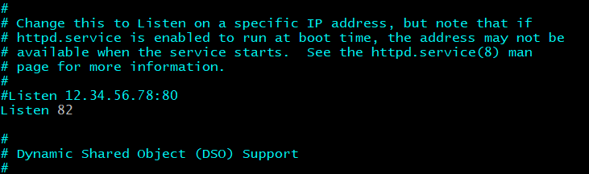

1. **Deploy a sample index.html file on Apache.**

To deploy

Cd /var/www/html/

Ll

Touch index.html

Vi index.html

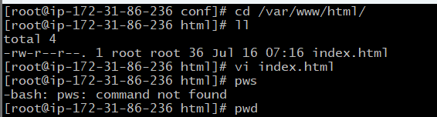

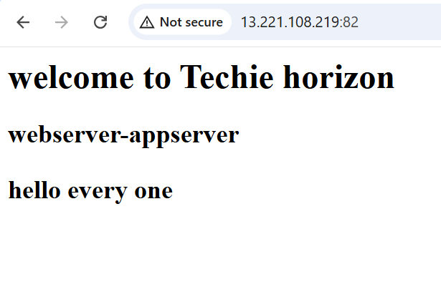

1. **Install Apache tomcat on port number 8082**

To install tomcat first we should have to install java (jdk)

yum install java

system ctl will not work for it

to install tomcat use this

wget <https://downloads.apache.org/tomcat/tomcat-11/v11.0.9/bin/apache-tomcat-11.0.9.tar.gz>

extract uing this

tar -xvzf apache-tomcat-11.0.9.tar.gz

to start

ls

cd apache-tomcat-11.0.9/bin

./startup.sh

Bash startup.sh

Check if Tomcat is running:

ps -ef | grep tomcat

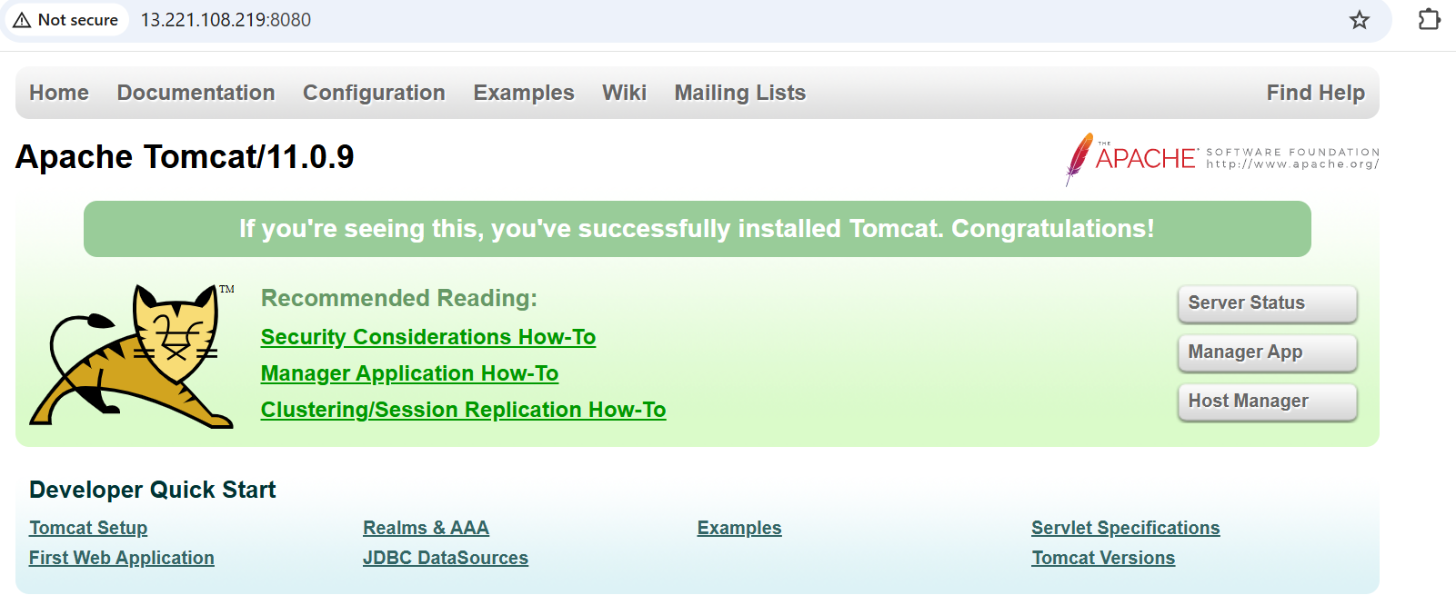

***To change port no:-***

cd /root/apache-tomcat-11.0.9

cd conf

vi server.xml

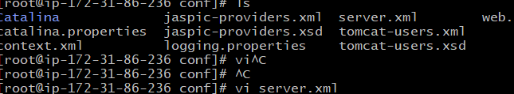

vi server.xml

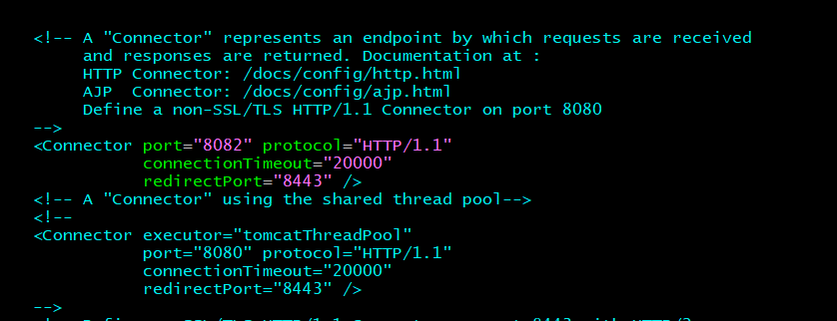

After updating the port no. we have to shutdown the tomcat and then restart for that we have

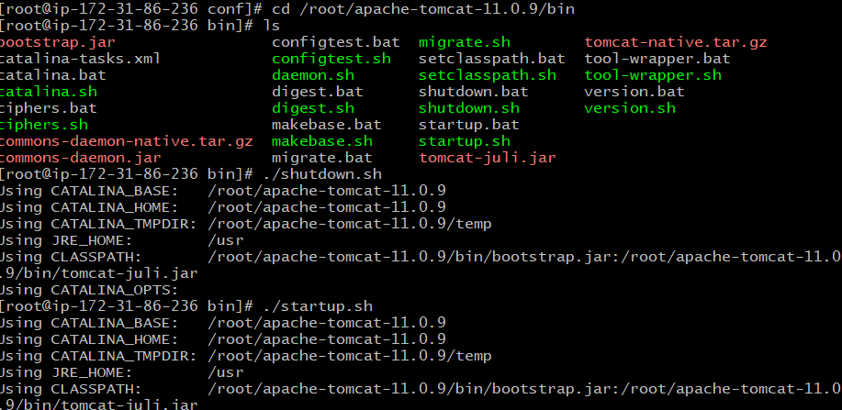

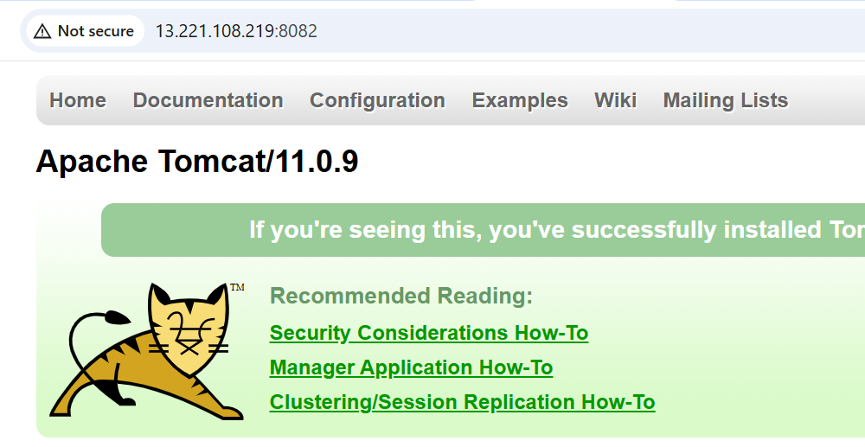

1. **Deploy a sample app on webapps**

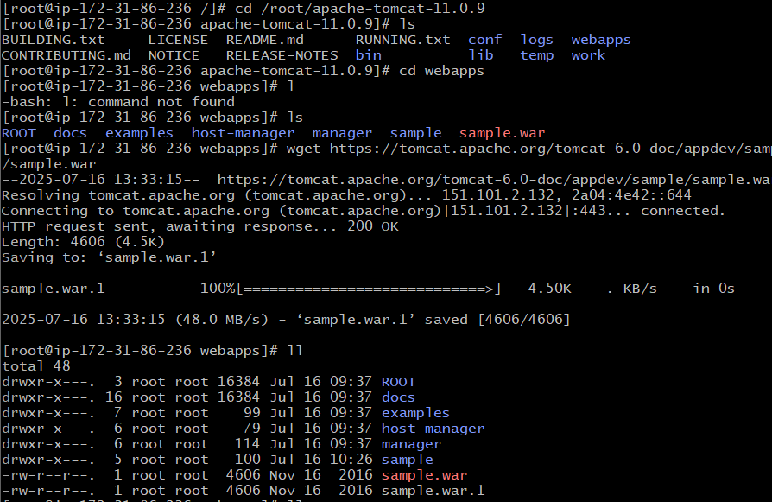

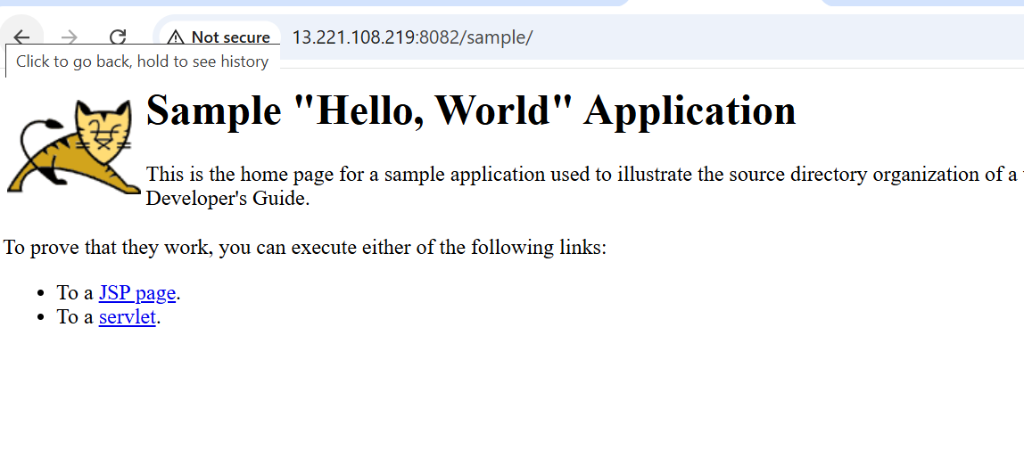

1. **Create a tomcat.service file for tomcat**

sudo nano /etc/systemd/system/tomcat.service

[Unit]

Description=Apache Tomcat 11

After=network.target

[Service]

Type=forking

User=ec2-user

Group=ec2-user

Environment="JAVA_HOME=/usr"

Environment="CATALINA_PID=/home/ec2-user/apache-tomcat-11.0.9/temp/tomcat.pid"

Environment="CATALINA_HOME=/home/ec2-user/apache-tomcat-11.0.9"

Environment="CATALINA_BASE=/home/ec2-user/apache-tomcat-11.0.9"

ExecStart=/home/ec2-user/apache-tomcat-11.0.9/bin/startup.sh

ExecStop=/home/ec2-user/apache-tomcat-11.0.9/bin/shutdown.sh

Restart=on-failure

[Install]

WantedBy=multi-user.target

chmod +x /home/ec2-user/apache-tomcat-11.0.9/bin/*.sh

sudo systemctl daemon-reload

sudo systemctl enable tomcat

sudo systemctl start tomcat

systemctl status tomcat

.

